Step by step instructions:
Important: Surveys will not automatically launch (there is not a default period). You must follow these instructions in order to have a survey initiated for your class.

1) Log into Canvas. Your dashboard will appear. Select one of your active courses. The side menu will appear. As long as students have one published course in Canvas, they are able to access all surveys.

2) Choose the Course Survey button. If the Course Survey button isn’t available, you might need to unhide it.
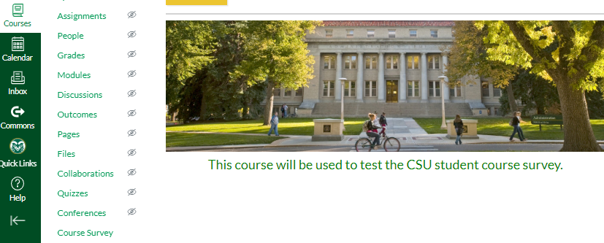

3) Login with your ename and current password. Your SmartEvals Dashboard will look similar to this: NOTE: If you are BOTH an instructor and student, to view the Instructor Dashboard, click on the House icon as shown below.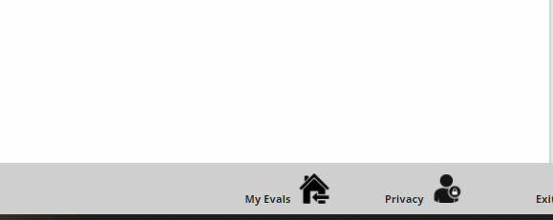

4) Select the course for which you want to initiate the survey.

Note: If you do not select survey day(s) of the week, the survey will not open for students to complete it. For example: Dr. Survey wants students to complete the survey during the weeks of December 6 to 19th. On December 6, Dr. Survey will access the Dashboard, choose Schedule Survey, and click the days of the week that apply (see instructions below). On December 20th, Dr. Survey will access the dashboard and unclick all of the days of the week to inactive the survey.

HELPFUL HINT: Set a Calendar Reminder for the day you want to activate the survey and then set another reminder on the day you need to deactivate/uncheck the boxes.

Faculty will have total control over individual survey begin and end days. (At this time, specific calendar dates are not available due to limited funds required for this customization. This option will be explored as funds become available). The survey can be administered one time throughout the semester. If you are co-teaching a course where you teach the first half and the other faculty member teaches the second half, then please administer the survey at the end of the semester. Each faculty member has a separate Instructor Question section for students to complete.

5) Click on “Schedule Survey”.

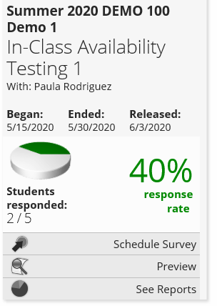
You can schedule the survey between these dates. The Released date is the date your report is available. Choose See Reports to view and Preview to see the questions on the survey.

6) Check the box next to “Enable limited window evaluations for this course” if not already checked.
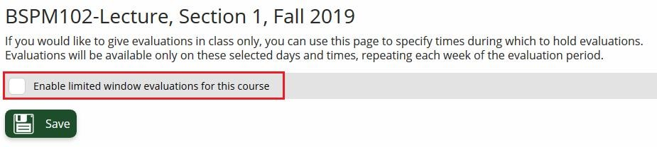

7) Select the days you would like the class evaluation to be available to students. The survey will remain open each of the days of the week for consecutive weeks until you uncheck the boxes next to each day of the week.

Note: Clicking the “Save” button without selecting days will disable the survey and not allow students to complete the survey.

It is highly recommended to allow “class” time for completion of the survey as this typically increases response rates.
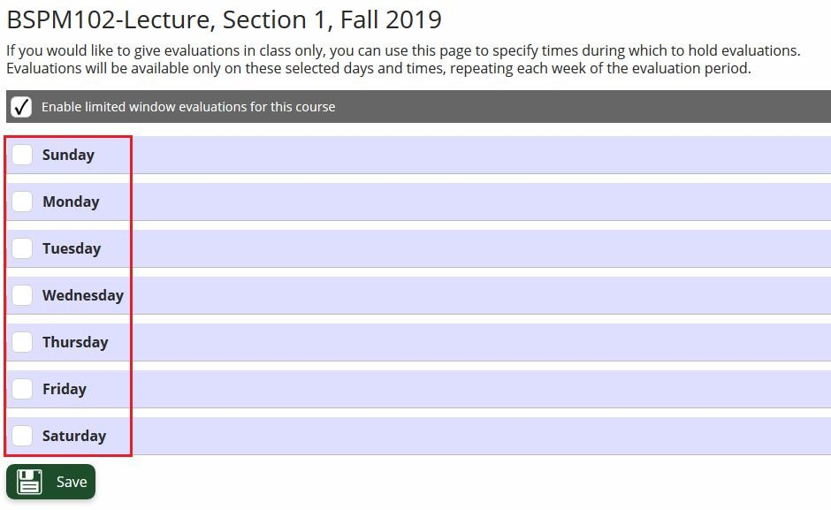
8) Adjust the start and end time via the drop-down menus.
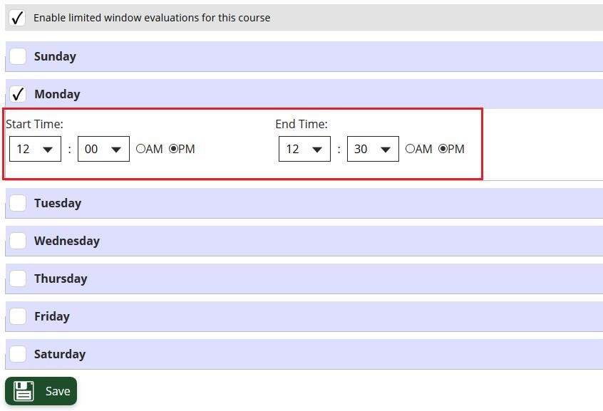
9) Click on the “Save” button. A yellow banner appears at the top of the screen stating your preferences have been updated.

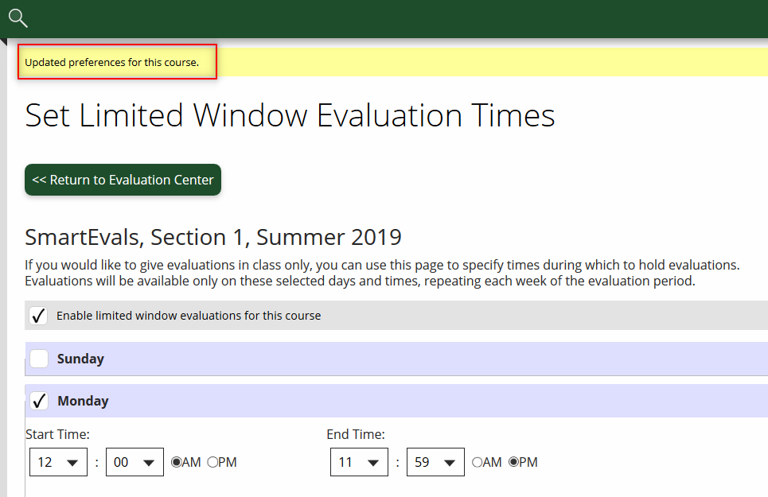

10) Click “Return to Evaluation Center” to select other courses or “Log out” to exit.
