Adding Questions to the Survey

Navigate to your dashboard through the Course Survey tab in Canvas or use this link: https://colostate.smartevals.com Log in with your ename and password
Your dashboard appears:
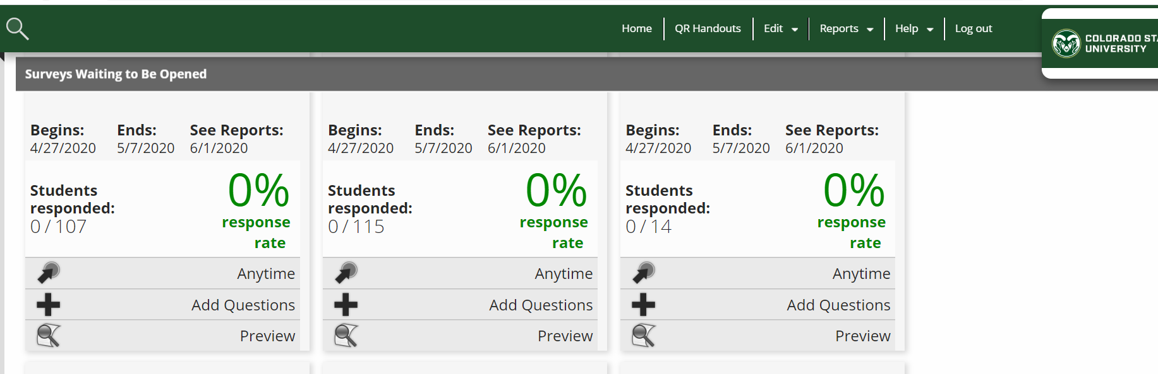
Click the + next to Add Questions. The following page opens.
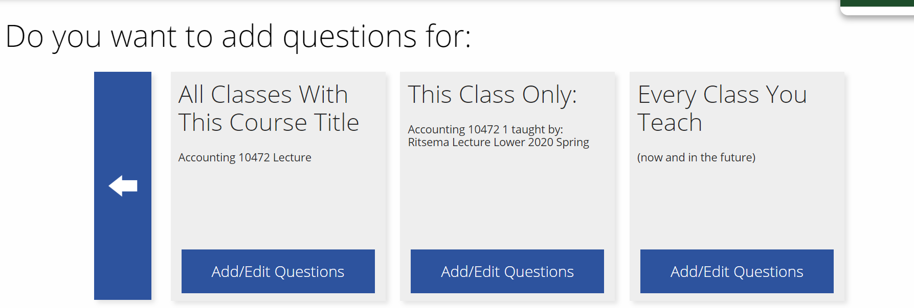

Choose the option that you want to use (if you plan to ask the same questions for every course, choose the last option).
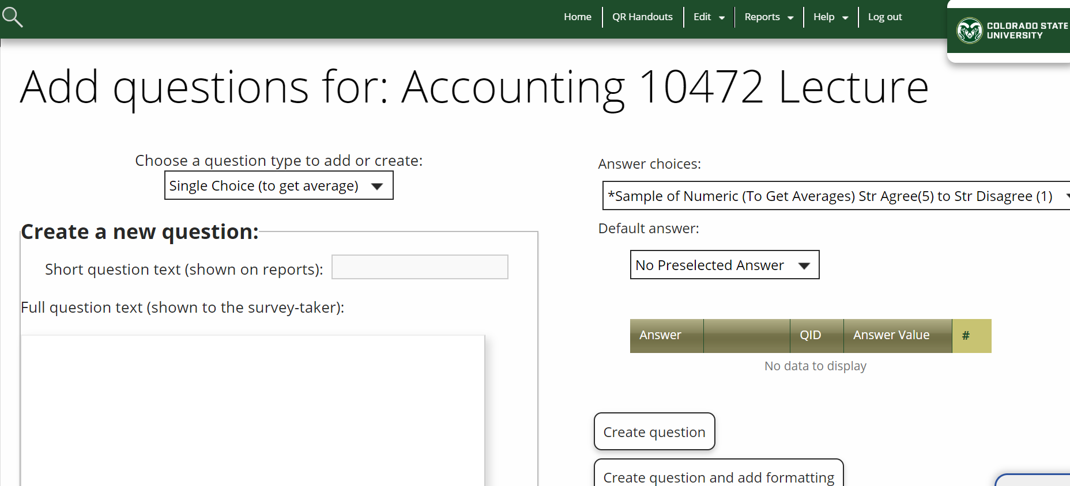
Construct your question using the formats above. You are able to add 5 additional questions.

